Guidelines For Application for Vendor Registration
- Vendor Registration Portal is supported on following Web Browsers:
4.1. Internet Explorer 8 and above
4.2. Mozilla Firefox 44.0 and above
4.3. Chrome 48.0.2564 & above
- Use http://byplws.bsesdelhi.com:8088/ to access the Vendor Registration Portal. If the portal does not open, open Chrome in Incognito mode by pressing Ctrl + Shift + N, and then paste the URL in the address bar.
- Go to the New Registration section, such as "Vendor Registration" or "Vendor Revalidation." If you already have a vendor code, click on "Vendor Revalidation." Otherwise, select "Vendor Registration."
- After log in, vendors need to submit information / documents in General, Business, Financial, Tax & Documents screens of Vendor Registration portal.
- Fill up entire details. Filling the (*) marked fields are Mandatory.
if you have registered on the Vendor portal, please log in
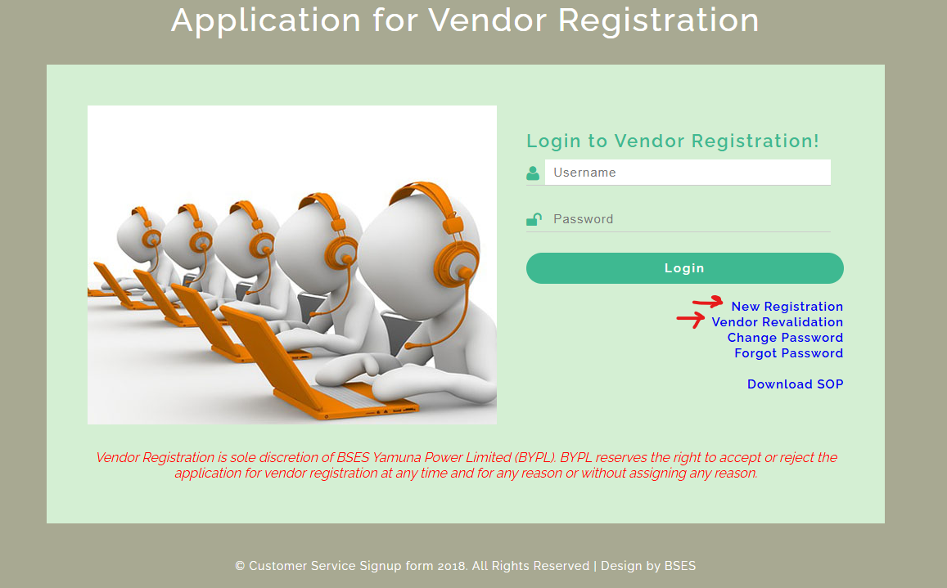

New Vendor Registration :-
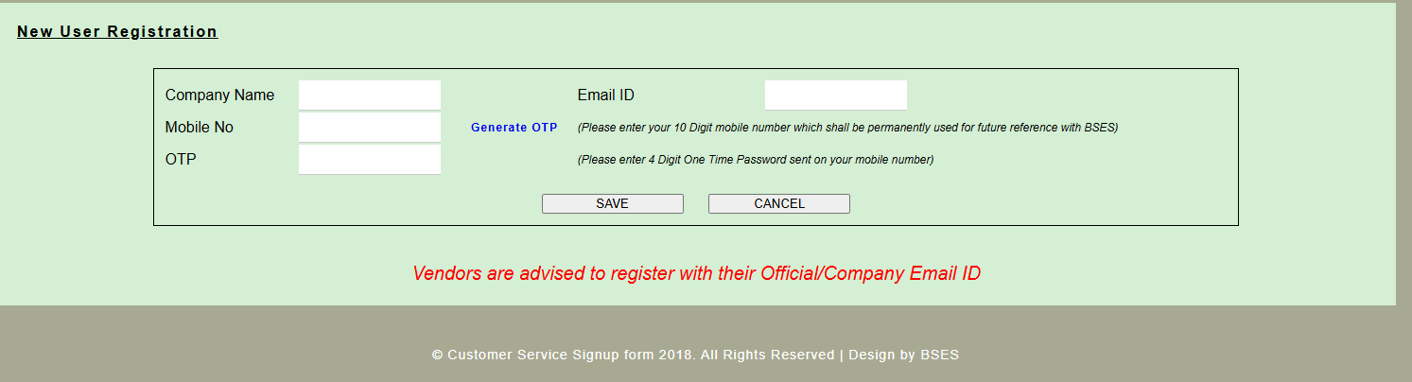
New Vendor Revalidation :- if you have vendor code
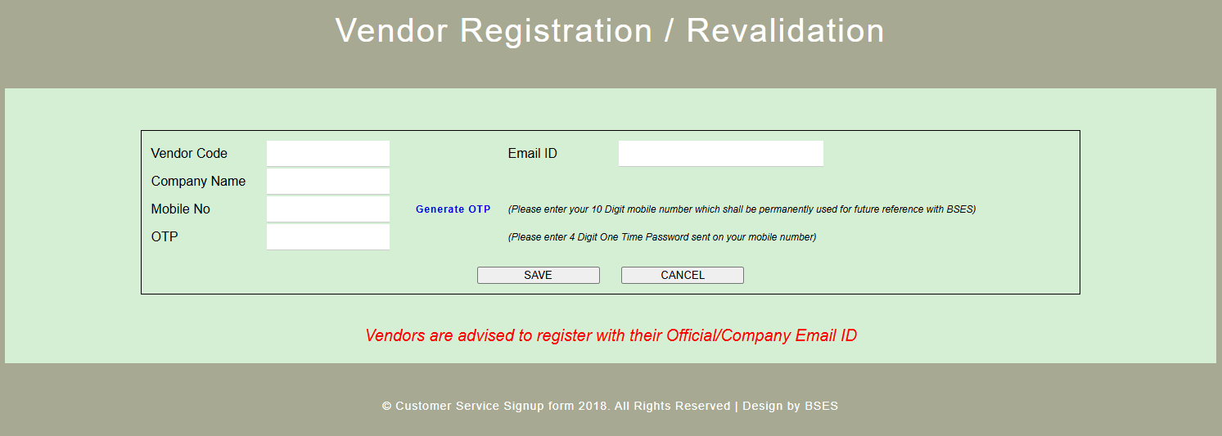
For Change Password :-
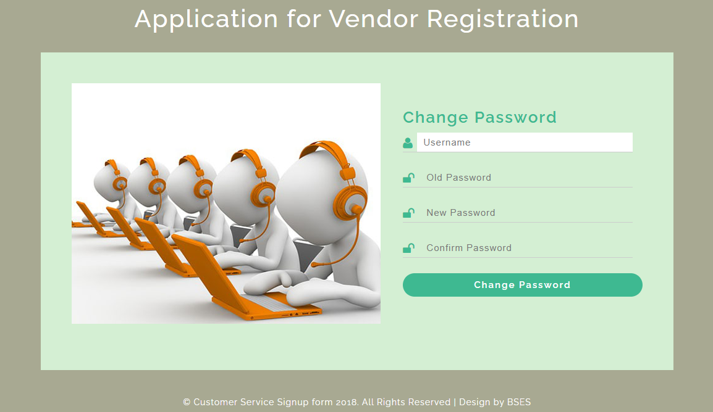

Forget Password :- Enter your User ID and click the "Forgot Password" button. The password will be sent to your registered email ID.
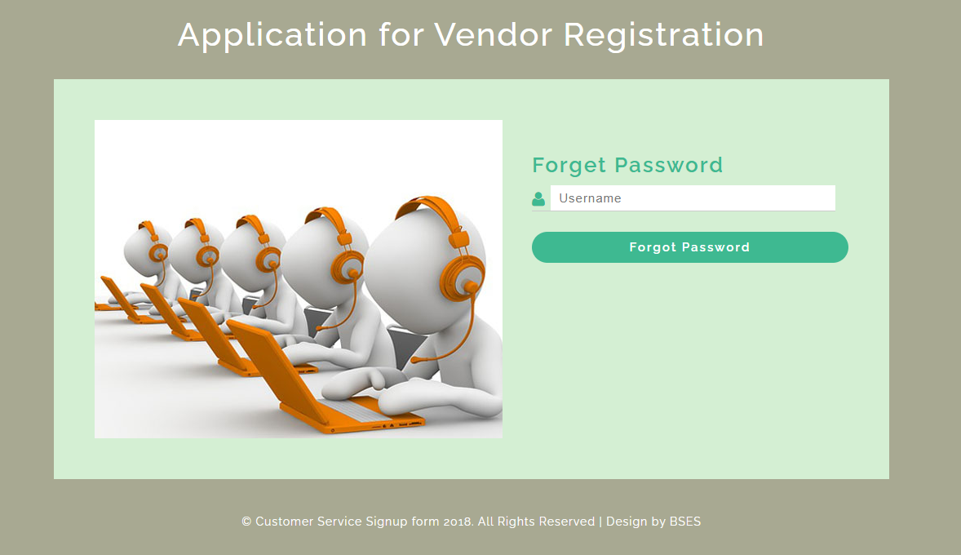

Application for Vendor Registration Home page

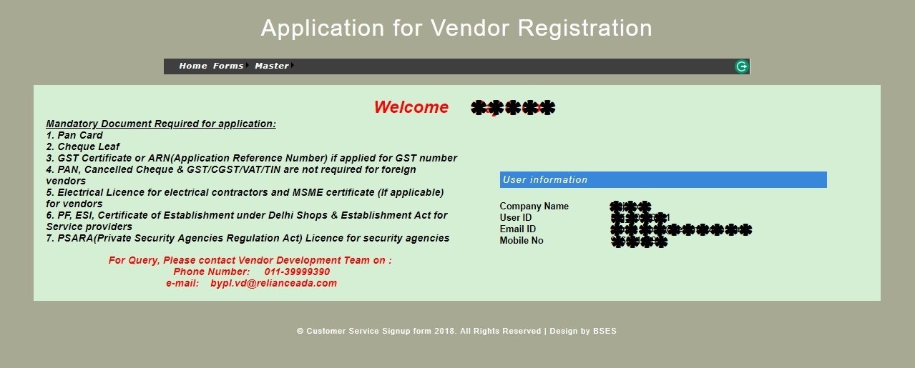

- Go to Forms and select General details.


General Details Screen
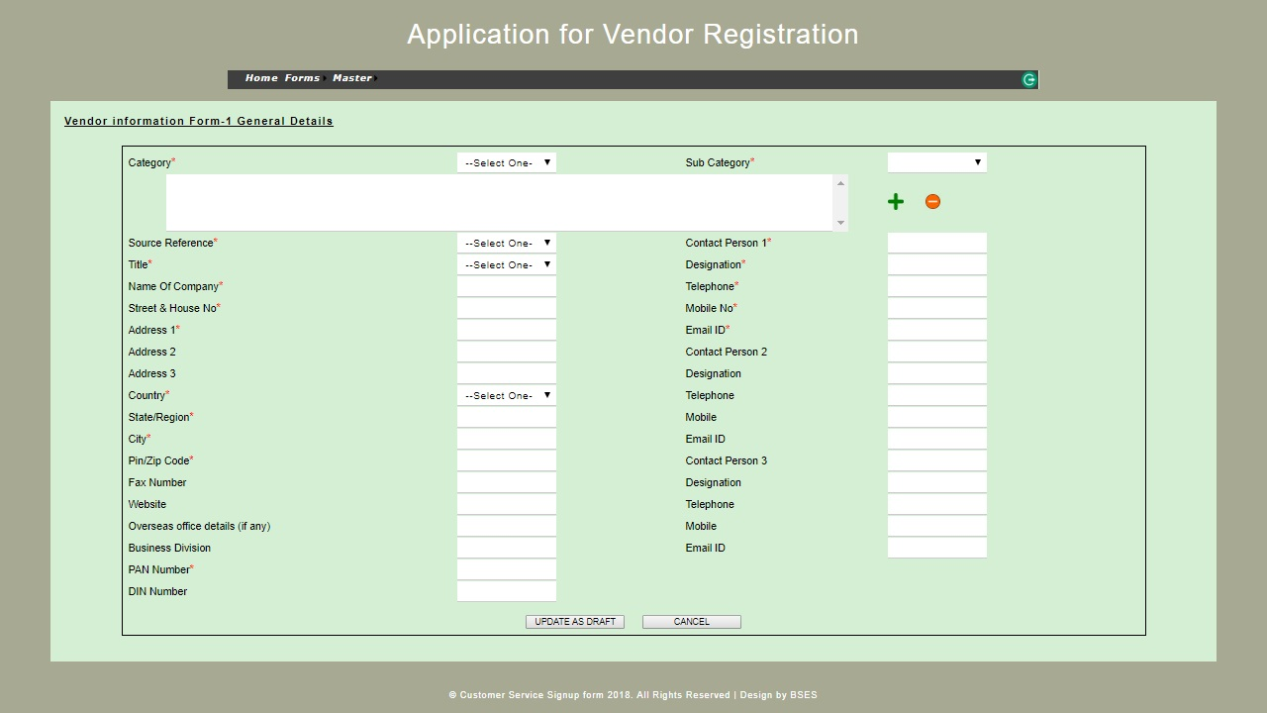

- Go to Forms and select Business details.


Business Details Screen
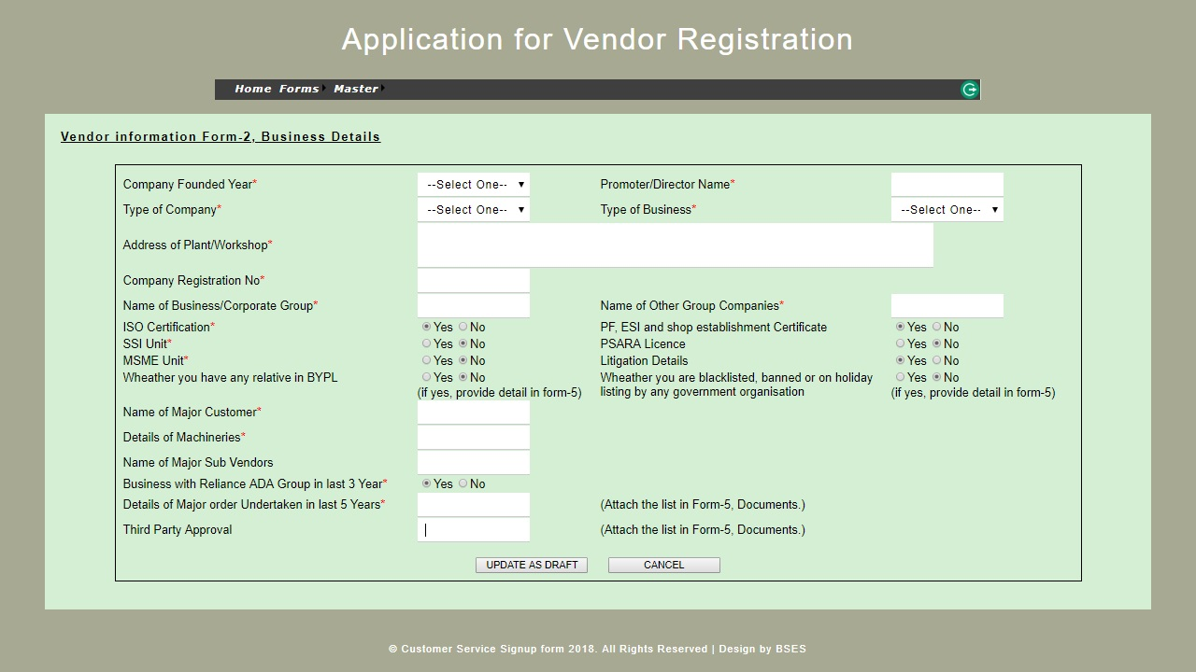

- Go to Forms and select Financial details.
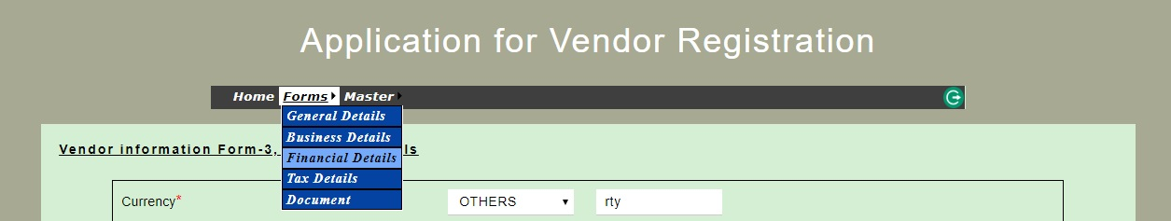
- Financial details: If you have IFSC code, select Yes and write that in the field IFSC code.
Note: If you’re a foreign vendor, no bank details required.
Note: It is important to put entire Account Number including preceding zeros if any.

Financial Details Screen
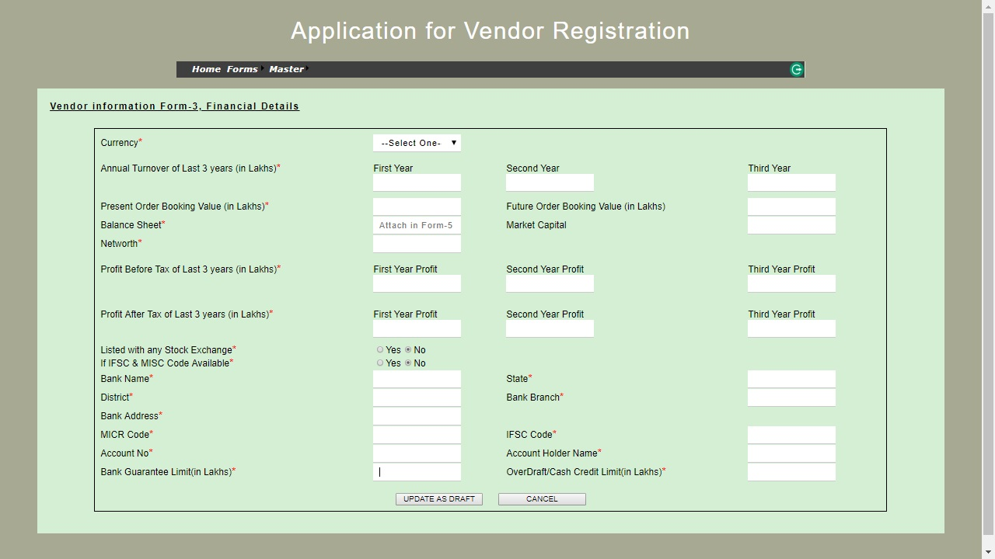

- Go to Forms and select Tax details.
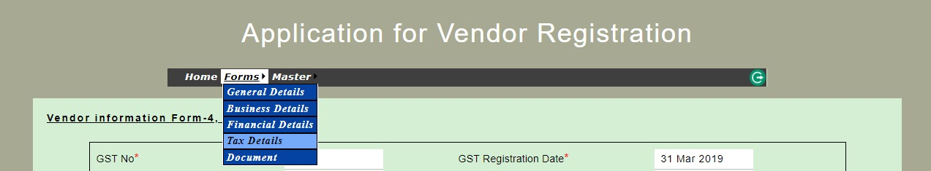

Tax details Screen
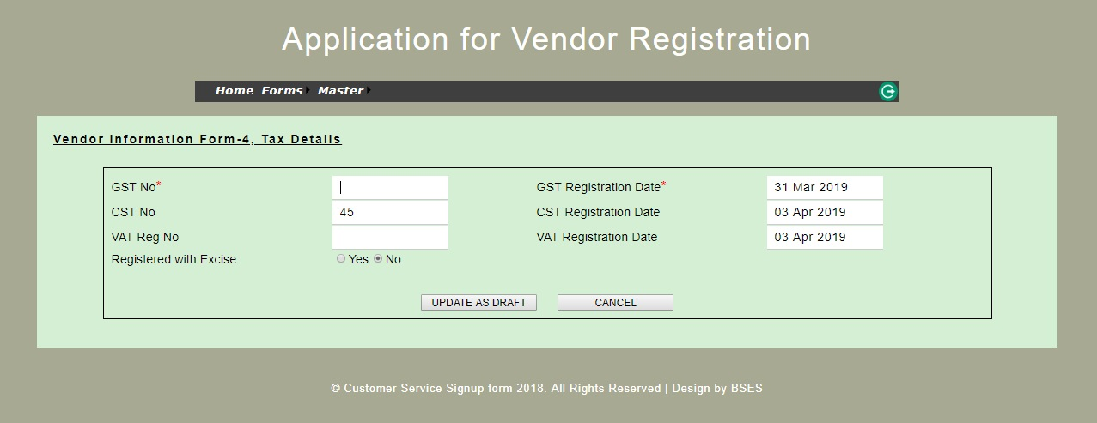

- Go to Forms and select Document.

- Upload the documents as per list of documents.
Documents Screen
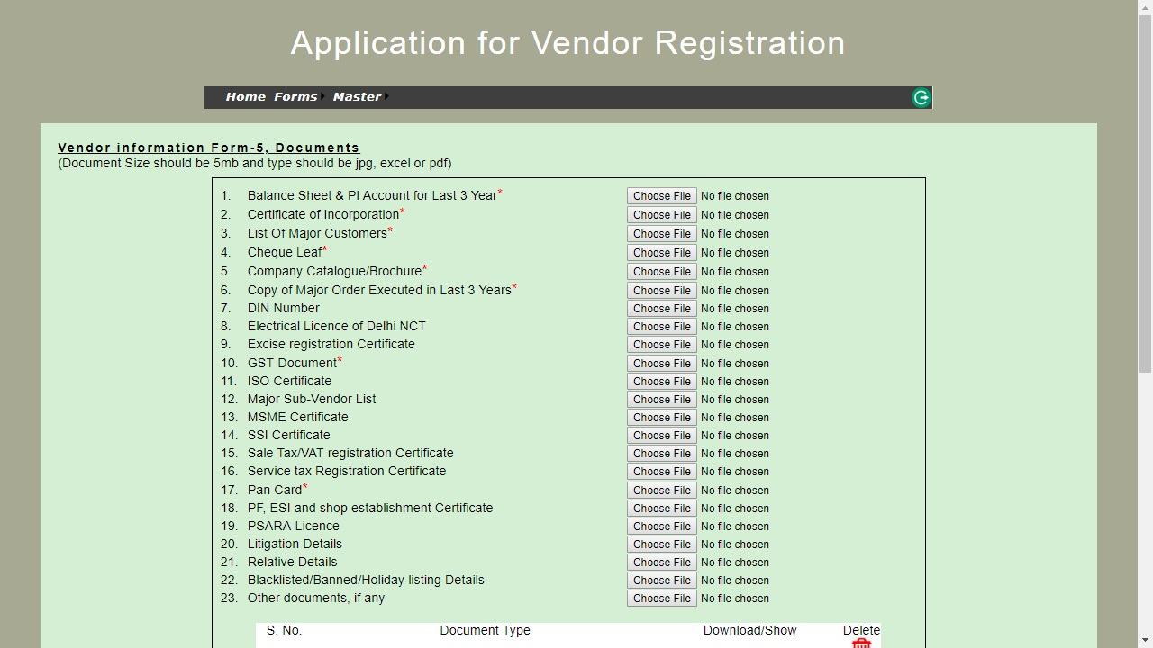

- Save & Submit the Application for Vendor Registration information.
- Vendor shall receive an email / SMS after submission of Application for Vendor Registration Form along with unique acknowledgment number.
- Vendor shall quote this acknowledge number for all future communications.
- In case of successful assessment, vendor will receive an e-mail from BYPL regarding further direction.
*****

